

Name/Section No.:.................../....
Kingdom of Saudi Arabia
Ministry of Higher Education
Dar Al Uloom University

Student's ID:...............

College/Program: BUSINESS ADMINISTRATION

Department: Finance & Banking

Academic Year | 2019/2020
Semester | Summer
Course No. | FIN201 / FIN1221
Course Name | Financial Management I /  Principles of Finance
Examination Type | Final
Form | A
Examination Date | 19/07/2020
Examination Period | 8:00 a.m. – 10:00 p.m.
Allotted Time | 2 Hours
Number of Pages including this page | 7

Important Instructions
This exam has three parts totaling | 12 Questions | Answer all five parts
Write your ID, Name, Session No. clearly on Page 1
You are allowed to use a scientific calculator/reference manual

معلومات هامة
هذا الامتحان مكون من خمس أجزاء، بمجموع | سؤال | أجب على جميع الأجزاء
أكتب رقمك الجامعي، واسمك، ورقم شعبتك على رأس الصفحة الاولى
يسمح باستعمال الالة الحاسبة بعد تفريغ الذاكرة / يسمح باستخدام الدليل المرجعي

Part No. | Part’s Marks | Student’s Mark | Tutor’s Name and Signature | Reviewer’s Name and Signature | CILO
1 | 3 |  | Dr. Ala'a Adden  &  Dr. Zahra Alnasser |  | 1.3
2 | 4 |  | Dr. Ala'a Adden  &  Dr. Zahra Alnasser |  | 1.2, 2.2
3 | 5 |  | Dr. Ala'a Adden  &  Dr. Zahra Alnasser |  | 2.3
4 | 4 |  | Dr. Ala'a Adden  &  Dr. Zahra Alnasser |  | 1.1
5 | 4 |  | Dr. Ala'a Adden  &  Dr. Zahra Alnasser |  | 1.4  2.1
Total | 20
Tutors grade in Red with signatures, Reviewer’s grade in green with signature

Answer All questions total 12 questions : all questions have same mark.

Part 1, answer all questions (1, 2, 3 , 4 and 5) ( 3 Marks)

Q1) The current and quick ratios both help us measure a firm's liquidity. The current ratio measures the relationship of the firm's current assets to its current liabilities, while the quick ratio measures the firm's ability to pay off short-term obligations without relying on the sale of inventories.
 | a. | True
 | b. | False
Q2) In general, if investors regard a company as being relatively risky and/or having relatively poor growth prospects, then it will have relatively high P/E and M/B ratios.
a. True
b. False
Q3:Which of the following individuals have unlimited liability based on their ownership interest?
I. General partner
II. Sole proprietor
III. Stockholder
IV. Limited partner
A. | I and II only.
B. | II and IV only.
C. | I, II, and III only.
D. | I, II, and IV only.

Q4) It is generally harder to transfer one's ownership interest in a partnership than in a corporation.
 | a. | True
 | b. | False

Q5) Diversification will normally reduce the riskiness of a portfolio of stocks.
 | a. | True
 | b. | False

Part 2 answer all questions (6 and 7) (4 Marks)
Q6) How much will $1,000 deposited in a savings account earning a compound annual interest rate of 6% be worth at the end of the following number of years?
- 3 years
- 5 years

Q7) You want to go to Europe 5 years from now, and you can save $3,100 every 6 months, beginning after six months from today. You plan to deposit the funds in a mutual fund that you think will return 8.5% per year. Under these conditions, how much would you have just after 5 years from now?

Part 3 answer all questions (8, and 9) ( 5 Marks)
Q8: The expected rate of return for the stock of Cornhusker Enterprises is 20 percent, with a standard deviation of 15 percent. The expected rate of return for the stock of Mustang Associates is 10 percent, with a standard deviation of 9 percent.
a. Which stock would you consider to be riskier? Why? (2 Marks)

b. If you knew that the beta coefficient of Cornhusker stock is 1.5 and the beta of Mustang is 0.9, how would your answer to Part a change? (1 Mark)

Q9) You have estimated the following probability distributions of expected future returns for Stocks X and Y: (2 marks)

Stock X
Probability | Return
0.5 | -10
0.4 | 10
0.1 | 40

2a- What is the expected rate of return for Stock X?
2b- What is the standard deviation of expected returns for Stock X?

Part 4 answer all questions (10 and 11) (4 marks)

Q10: Why would you anticipate a lower P/E ratio for a typical natural gas utility than for a computer technology firm, such as Apple?

Q11: Briefly explain what problems may be indicated by an average collection period that is substantially above or below the industry?

Part 5 answer the following question (4 marks)

12- use the numbers from the following financial statements to Calculate the following ratios, explain your results?

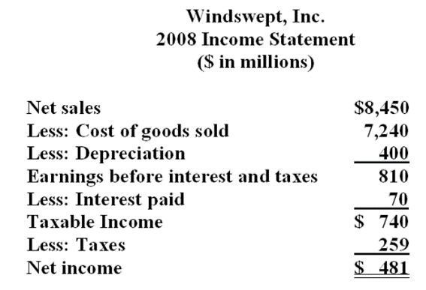
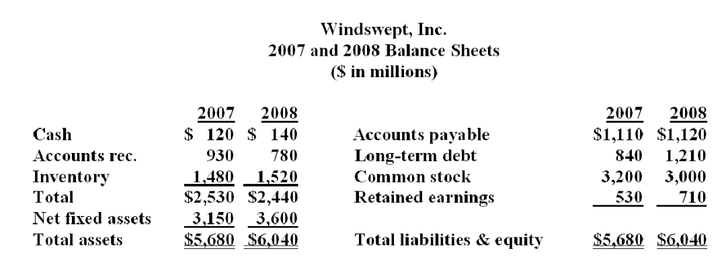
- What is Quick ratio for year 2008?

- What is inventory turnover in 2008?

- What is interest earned ratio?

